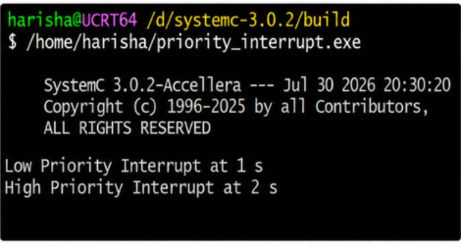#include <systemc.h>

SC_MODULE(priority_interrupt)
{
sc_event low_int, high_int;

void low_ISR()
{
while(true)
{
wait(low_int);

cout << "Low Priority Interrupt at "
<< sc_time_stamp() << endl;

wait(3, SC_SEC);
}
}

void high_ISR()
{
while(true)
{
wait(high_int);

cout << "High Priority Interrupt at "
<< sc_time_stamp() << endl;

wait(1, SC_SEC);
}
}

void generator()
{
wait(1, SC_SEC);

low_int.notify();

wait(1, SC_SEC);

high_int.notify();
}

SC_CTOR(priority_interrupt)
{
SC_THREAD(low_ISR);
SC_THREAD(high_ISR);
SC_THREAD(generator);
}
};

int sc_main(int argc, char* argv[])
{
priority_interrupt obj("Priority_INT");

sc_start(10, SC_SEC);

return 0;
}

